 | BABY  BEREAVEMENT PACK  Request Form | 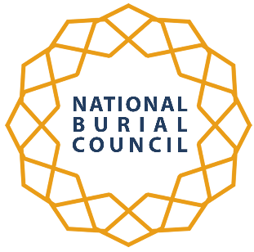

Please complete the following request form giving all the details requested and return it by email to
info@nbc.org.uk
Thank you for your request. A member of our team will be in touch with you soon. If you have not received a response from us within seven days, please let us know.
Jazakamullah.
The Blackburn UK Trust – NBC
YOUR DETAILS
Your Organisation
Address

Your Contact Name

Position
Mobile Telephone Number
Contact E-Mail
HOSPITAL - TRUST DETAILS
Details Of Hospital Trust

Address

Contact Person
Job Title
Telephone Contact
Email

Do you require A sample for approval by the Trust.

The number of Packs required.

Delivery Address:

Have you ordered Packs Before | Yes |  | No

